Got Library Apps?
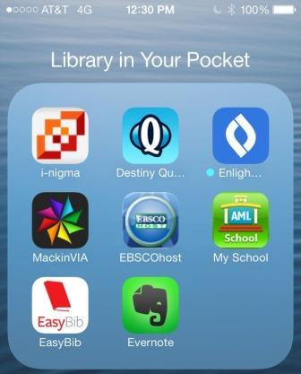
Access your library anytime, anywhere
These QR codes should take you to the App store where you will be able to download
and install these free apps. Got Android? Check Google Play to see if your device has a related app.
Note: Students should read age restrictions before downloading apps.
See Ms. Hooper for more information!

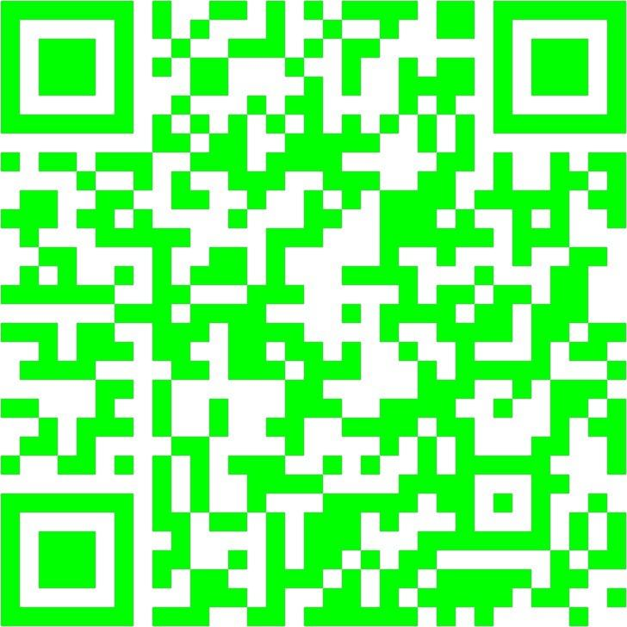 | 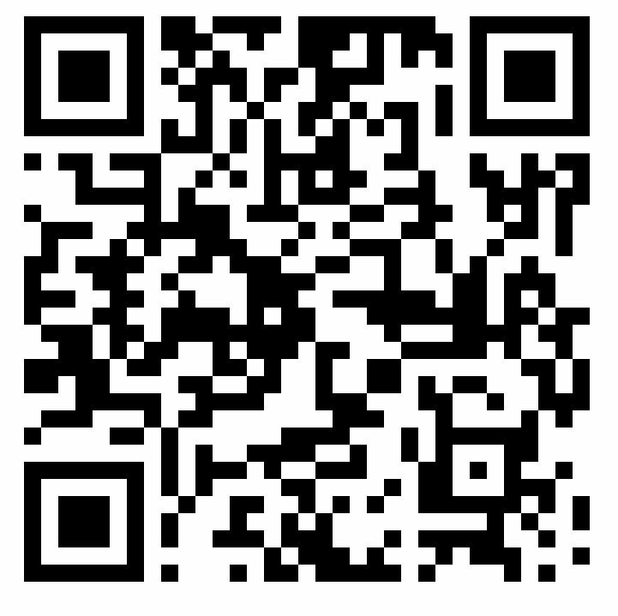 | 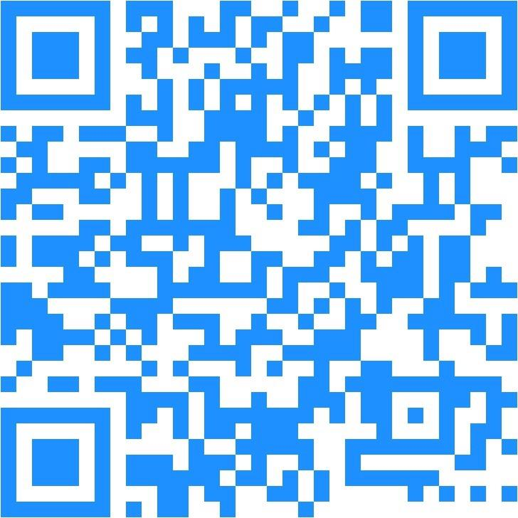 | 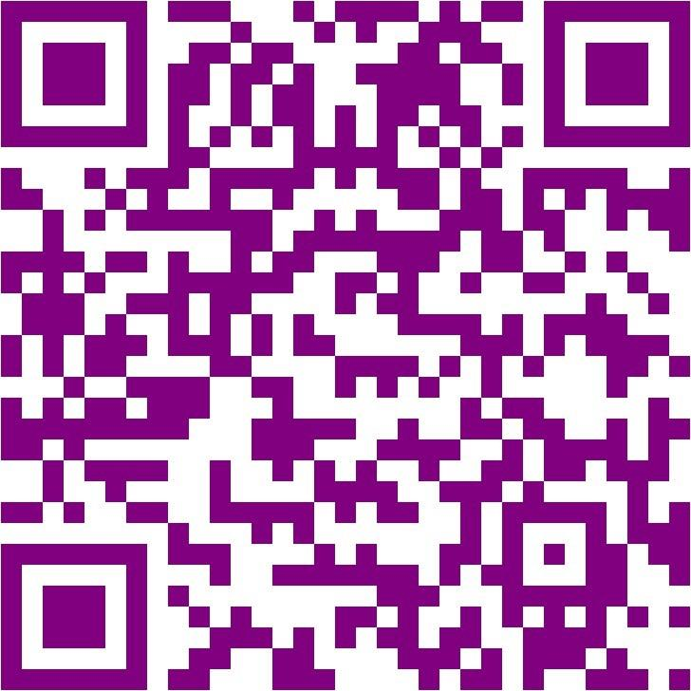
i-nigma: QR code reader  Download app to scan these QR Codes  http://bit.ly/VryuLf | DestinyQuest: Interact with our Destiny Catalog.  http://bit.ly/1bfkvfS  URL: destiny.fort-mill.k12.sc.us | Follett EReader: Access to ebooks from Follett  http://bit.ly/17fH0EH | MackinVia :Access to ebooks from Mackin  http://bit.ly/17IUROf
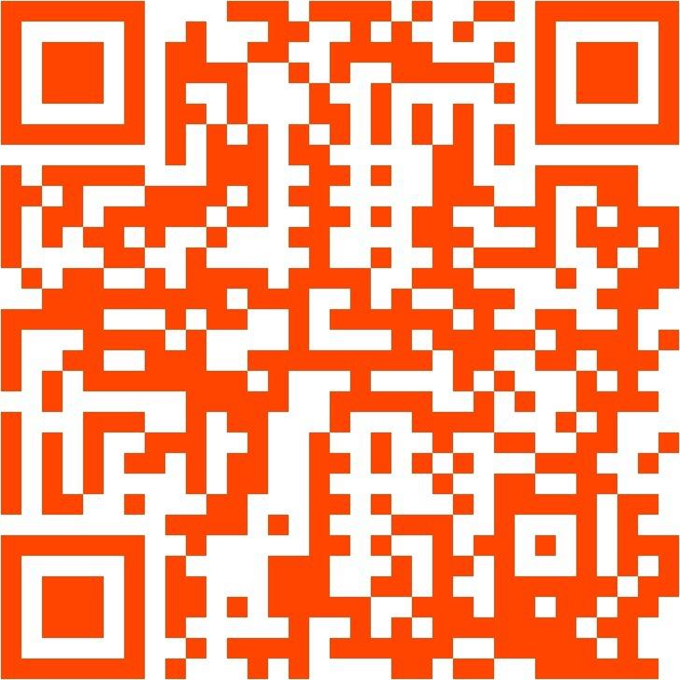 | 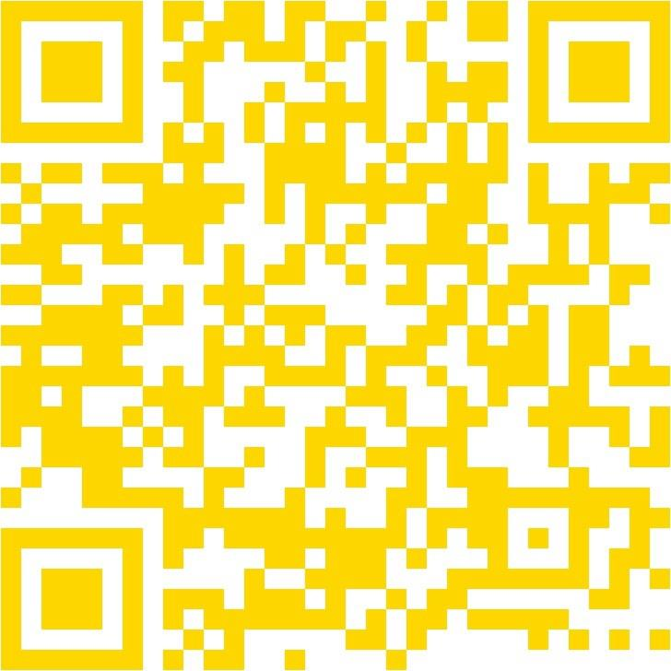 | 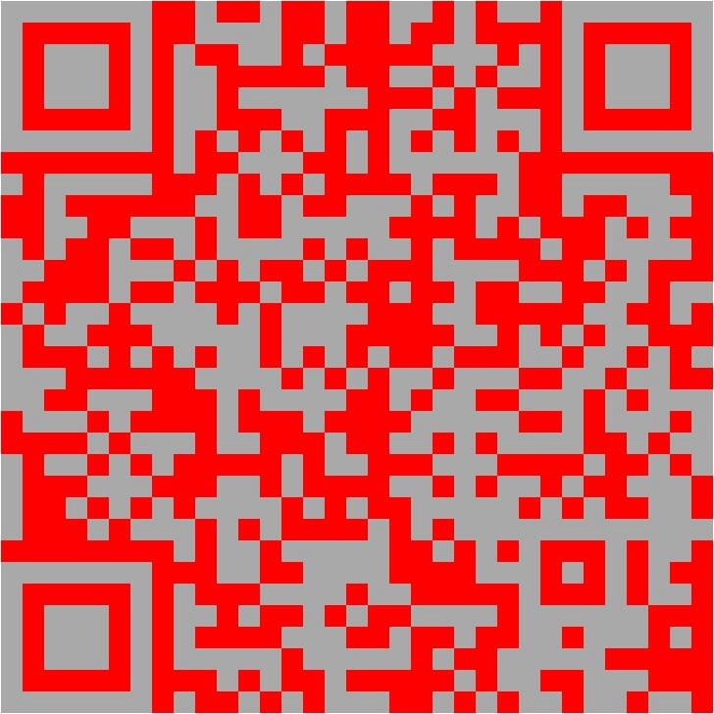 | 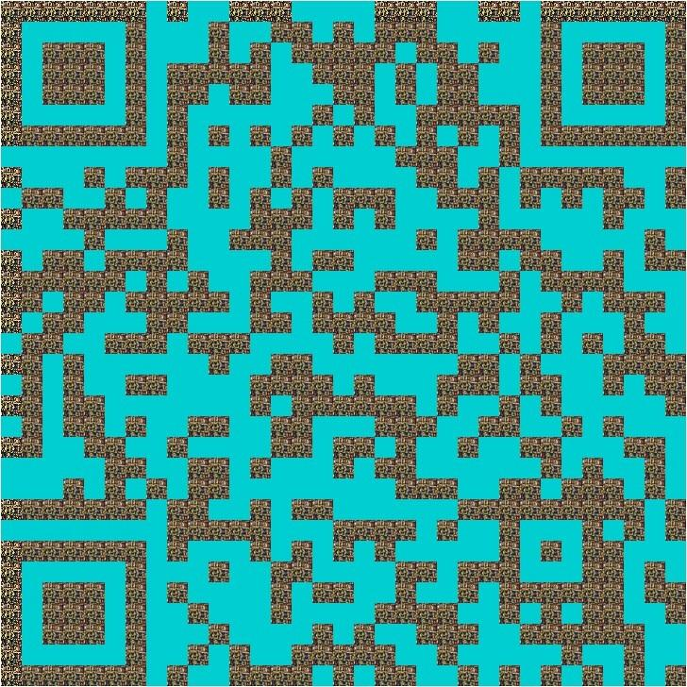
Free Ebook App: Access classic books for FREE!  http://bit.ly/VVdzfe | Gale Databases: Use our Discus Password to access  http://bit.ly/148DvKv | EasyBib: Create MLA citations. Make sure to double check them!  http://bit.ly/11RxO4L | Fancy QR Code Generator: Make your own QR Codes  http://bit.ly/17IVRll

